Swapping self-fulfillment for a family heritage: filming ethnicity in James Gray’s two movies “We Own the Night” and “Two Lovers”.

Nausica Zaballos, PhD American civilization (Paris IV Sorbonne), independent scholar.
Key words:
James Gray, Eastern European family, Brighton Beach, Brooklyn, filming ethnicity.
Table des matières
Introduction: 1
A depiction of invisible racial conflicts 2
Filming ethnicity: linguistic and visual signs 3
Ambivalence and double allegiances 6
Stuck in a role 8
Conclusion 9

Introduction:
“We Own the Night” and “Two Lovers”, both directed by James Gray, are set in a distinct New York neighborhood but all have in common the depiction of a specific milieu: the Eastern European family. Despite their obvious genre dissimilarities (a classic police movie and a romance), James Gray’s films explore the issue of coping with one’s family heritage, be it through rejection or reinvention. The Eastern European family –Jewish or not- provides material sustenance, work acquaintances and potential wedding mates. It is the group that smothers or fosters personal identities, thus shaping power relations between the individual and the outside world, the would-be adult and other authority figures. Gray’s lead characters are often portrayed as prodigal sons: they eventually achieve a sense of identity by submitting themselves to a moral order re-enacted through recognition of family values and obligations. However, the geography at stake in Gray’s movies is elusive and embodies the numerous pledges exchanged, denied or betrayed by the versatile representatives of the ethnic communities living and working in Brighton Beach, Queens or Brooklyn. This article will try to show to what extent the clashes depicted between individual and family mirror less visible but stronger ethnic and generation-gap tensions. A reflection on the process of growing up, Gray’s films are more than traditional Bildungsroman. In making the hero’s family distinctively ethnic, Gray further questions the liberty of the individual against the weight of community impetus: he highlights the power gained and lost through acknowledgment or denial of one’s “ethnicity”.

A depiction of invisible racial conflicts
According to some critics, each of Gray’s pictures portrays the moral dilemma of individuals torn between their allegiance towards family values and their longing for freedom and personal self-fulfillment. James Gray’s movies revolve around this issue but they’re more than that. The conflicts that arise from these apparently contradictory ambitions highlight underlying ethnic tensions. Gray relies on the use of linguistic and visual clues to hint at the necessity for individuals to ascertain or conceal their racial identity.
Thus, “We Own the Night” depicts the moral and social evolution of Bobby Green (Joaquin Phoenix), born Bobby Grusinsky, son of a praised police captain, and crowned “King of the Night” under his new identity by Marat Buzhayev (Moni Moshonov), owner of the club El Caribe. The club is apparently the place where ethnic identifications are silenced by music and the desire to party. Porto Ricans, Italians and other groups flock in to listen to good music and occasionally get stoned.
Bobby’s brother and father are police officers in New York City. To them, Bobby is a bit of a renegade, a good-for-nothing who hangs around with the more despicable fringes of society.
The opening scene shows how the two worlds collide and cannot be reconciled. On the one hand, the cops who perform their duty “own the night”. They wear this preposterous claim on their badges. On the other hand, Bobby owns the night because from his office, on top of the disco, he hands out compliments to his many would-be friends at El Caribe. On his way to the celebration organized for his father by the New York police force, he stops by his adoptive family where he’s warmly greeted by Marat’s wife and children. However, appearances are deceptive and Bobby consents to be the patsy of both parties. Bobby believes that by becoming Mr Green, he frees himself from any ethnic allegiance. Yet, he is reminded that he works for Russians and that, in the late 80’s, the Russian Mafia had succeeded in eliminating any competition in NY. Bobby is urged by his father to side. He cannot be the man in the middle, the man with no identity. Bobby has defined himself in opposition to his family Manichean vision of the city but his father resents that he changed his name.
The safe and decent world of the police (mostly made up of Poles from the first immigration wave, highly represented in the police force) is opposed to the filthy world of the night where Russians and Latin-Americans lurk. The ordinary racism of Captain Grusinsky (Robert Duval) belies the resentment of the first immigrants. Well-integrated and at the same time proud of their origins which they never fail to display ostentatiously to the world, they scorn the new immigrants whom they deem vulgar and troublesome. Thus, Burt Grusinsky does not approve of his son’s Porto Rican girlfriend: “Who did you hook up with?” What is foreign is unworthy of the family. What is outside the family contaminates and unmans the males according to Bobby’s brother, Joseph (Mark Wahlberg) who says to Bobby: “Be a man instead of fucking your Porto Rican.”
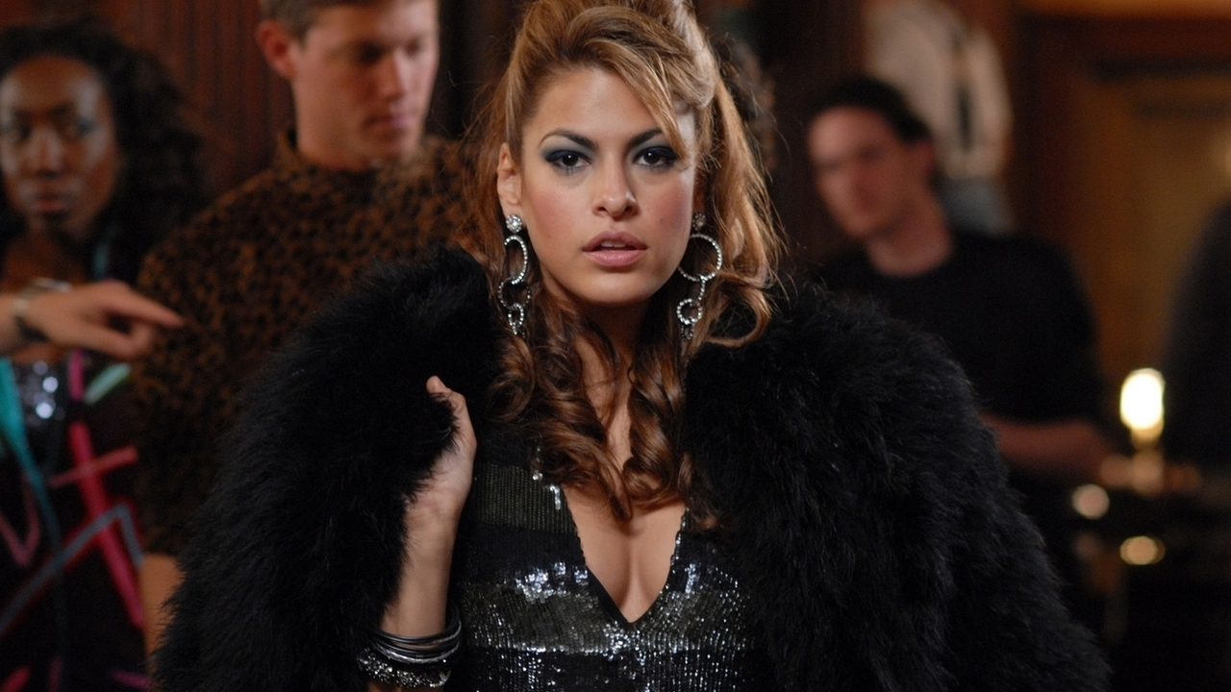
Even if the audience could argue that most of those representations are based on stereotypes, Gray eventually doesn’t question the teaching of those images. His tour de force is to show that despite the general call for political correctness and the condemnation of racial categorizations, there is some truth in those biases.
Bobby wants to remain neutral and seems to fence off perceptions that he believed are based on a racial vision of the world. Yet, he will learn that the signs of ethnicity are meaningful and reveal the true selves of people.

Filming ethnicity: linguistic and visual signs

What seems forbidden and impossible to achieve for Gray’s lead characters is to deny or cover up their ethnicity by mixing religious symbols or associating with foreigners. Vadim Nezhinski (Alex Veadov), the Russian drug-dealer who eventually kills Bobby’s father in “We Own the Night”, is Bobby’s mirror image. After the police cops raided the club, Vadim is faced with Joseph. The Polish officer sneers at him because he wears a cross and a Jewish star. Vadim, has much in common with Bobby, his nemesis. Crushed by a strong paternal figure, both struggle to make their own name, both keep a family secret. Vadim must not reveal that his uncle is the head of the Mafia and Bobby must not let out that his father is the head of the New York police department. Thus, it is no surprise that Gray uses the charcoal metaphorically to hush up Bobby during the raid. As a symbolic device, the charcoal underlines the need to silence someone who cannot be trusted. Vadim and Bobby are the sons who shame the family. Vadim comes from the Russian word vaditi which means "to cheat" or "scandal maker". Vadim brings havoc because he may lead the cops to his uncle, thus staining the family reputation. Bobby is Green because he’s immature, unreliable. The fear of exposure drives them both in the first part of the movie. Bobby fears he might be considered a fraud if his friends discover he’s the son of a Polish cop. Yet, it’s not the charcoal that makes Bobby choke but his incapacity at stating his true name, his father’s name.
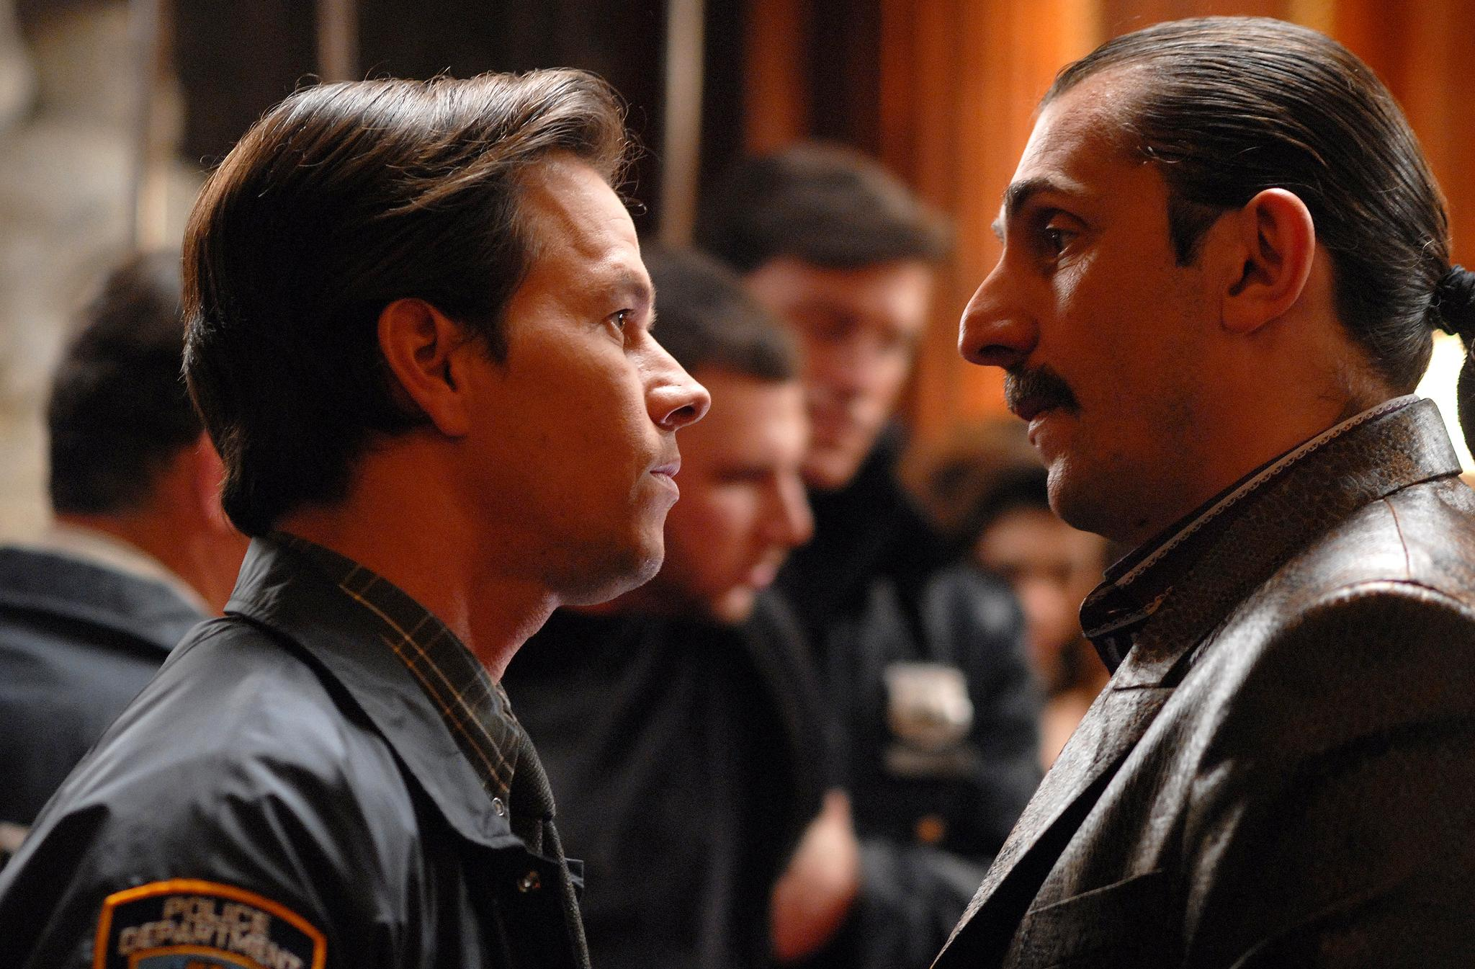
Through its ethnicity and its relationship to a specific milieu (the police or the mafia), the father’s name reveals the legacy the sons refused to endorse. This love-hate relationship towards the father and his power asserted by his name also pervades the motion picture soundtrack when Louis Prima is heard singing “Should I reveal how I feel, should I confess I love you, should I unfold I love you?” in the song “Should I?”
Bobby is so self-conscious of the danger of being exposed as Grusinsky that he becomes oblivious to the signs of ethnicity he’s surrounded by, such as his best friend’s surname. A buffoon drug-dealer, Jumbo deals cards at Bobby’s poker games. Yet, Jumbo’s real surname is “Falsetti” and his real trick is to deal information to the most offering. Jumbo eventually ends up embodying stereotypes about Italians: cunning, deceitful, cowardly and gossipmonger. Responsible for Bobby’s father’s death, Falsetti (Danny Hoch) also distorts language in order to give meaning to ethnic reality. Jumbo doesn’t seem to be aware that a little joke he made about a runaway Jew questions Bobby’s honesty. When language is not manipulated on purpose by a character to expose Bobby’s lies about his family, language seems to have a power of its own. Thus, Vadim, unaware of Bobby’s family heritage, says: “We’ve got all the police officers’ names on a list.” Bobby’s twinges are not what make Vadim suspicious. Vadim discovers that Bobby has betrayed him because he notices that Bobby holds two objects that can be used for the same purpose: a lighter and matches. Bobby’s flinching double allegiance is suggested by two almost identical objects. If language cues failed to reveal any clues to the protagonists, lies will be exposed through seeing objects. Vadim’s henchman cut his throat at the precinct to avoid speaking. Vadim dismissed his body-guard because he spoke too much. However, even if Vadim and Bobby are afraid of language and what it might reveal about their intentions, it is through observation that betrayals, lies, true allegiances and ethnicity are revealed.
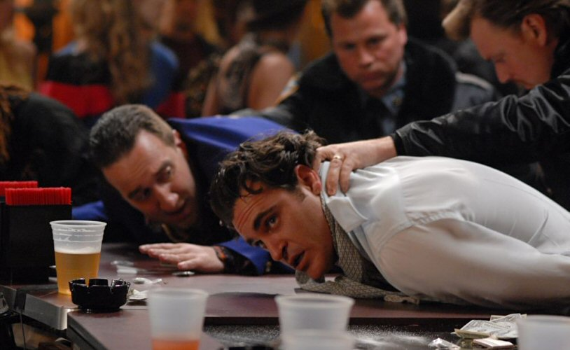
The topoi of the blind man is suggested by Marat Buzhayev’s apparently innocuous gesture at supper. He pulls out the eyes of a fish while smiling when asked about the fur business. Bobby will eventually discover that Marat is the head of the Mafia and uses the furs to hide the drugs in. Once his distinctly ethnic father’s name is revealed, Bobby will over-interpret the signs of ethnicity. Thus, spotting a group of Latinos at his father’s funeral, Bobby believes they are laughing at him. The audience is left wondering whether the Porto Ricans made fun of Bobby. Yet, this exchange of meaningful or deceitful glances underlines Bobby’s commitment to acknowledge his origins and become a cop like his father.
Fathers had to die (symbolically or for real) for brothers to reconcile and become what they were meant to be. Each brother was playing a role: Bobby that of a rebel and Joseph that of the good son. Eventually, Bobby turns out to be the toughest of the two. He’s got the guts and the violent temper needed to carry out the family revenge while Joseph, who always complied with what his father ordered, crawls for protection and begs to be appointed to an administrative job within the police. However, for Bobby, it’s just another mask. By giving up his friends, lover and job to become his father’s avenger, he’s never been such a prisoner of his ethnicity and his father’s persona. He comes to personify what psychiatrists call “the borderline type” who multiplies the “as if personalities” to fulfill his role models’ desires.

Ambivalence and double allegiances

“We Own the Night” ends with the two brothers saying “I love you” to each other at the police academy graduation ceremony. Bobby believes he has spotted his Porto Rican girlfriend among the audience. Yet, he realizes he’s only been deluded by his sadness.
By becoming what his father wanted him to be, Bobby has betrayed his inner self: he has become the fraud he was frightened of.
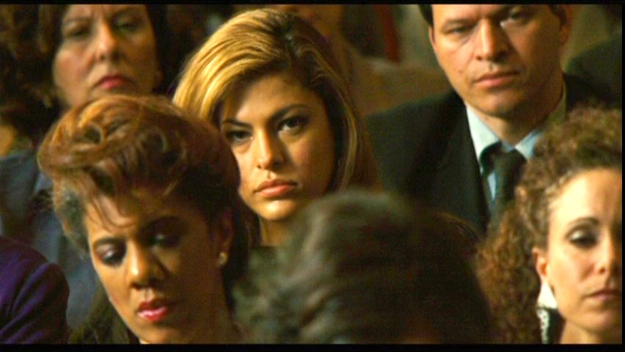
In “Two Lovers”, Leonard Kraditor (Joaquin Phoenix), son of a traditional Jewish family, embodies all the contradictions Bobby went through. Having been dumped after his girlfriend discovered he suffers from a bipolar condition, Leonard goes back to live with his parents in Brighton Beach. He attempts to drown himself but he’s rescued by passers-by who are clients at his parents’ laundry. “Two Lovers” starts where “We Own the Night” ended. Leonard has already given up his independence and his dreams. He’s a crushed 30 year old man who lives like a teenager but behaves like an old resigned man.
His ambivalence, his double allegiance is signified by his pathology. Falling in love with two completely opposed types of women seems a normal step for him. Yet, what the title suggests is linguistically deceptive. Leonard didn’t fall in love with two women. Leonard fell in love with a “shikse” but ended up with the one he didn’t love, the serious boring Jewish girl his parents chose for him. Leonard’s secret dream, long abandoned, was to make it as a photographer. What prompts Leonard to take pictures is to reveal to the representatives of normalcy the weirdness and contradictions of the world shown through dilapidated, run-down and abandoned buildings. The estrangement stemming from the feeling of not behaving like others must be mirrored in objects which seem despised, forgotten or discarded. Yet, Leonard is forced to take “ordinary” pictures of ordinary pleasures: a wedding, a Bar-Mitzvah. Those social rituals signify to the community the individual’s coming of age. At the Bar Mitzvah, everything is designed to stage the promise of happiness. Yet, the hero doesn’t seem to fit into this picture and his phone rings at the moment his future in-law introduces him to the guests as his daughter’s chosen husband. His parents’ walls are covered with pictures portraying happy couples. The hero is overwhelmed by secure promises that depend on his faithfulness to the family roman. For this Jewish family, love at first sight doesn’t exist and shouldn’t exist. Love is a mutual contract validated by the parents of the future couple. The process of finding a potential mate is almost carried out as a business plan. Sandra (Vinessa Shaw), the nice Jewish girl is viewed as the enduring type who by her normality will make up for her husband’s eccentricities. In “We Own the Night”, security was provided by the club: Bobby could look at the dancing crowds and their happiness reassured him. In “Two Lovers”, security is brought about by the same kind of voyeurism. The pictures are as mute and as indifferent as the dancers. You stare at them but they don’t express anything apart from contentment. They don’t look back at you questioning your identity and behaviors.
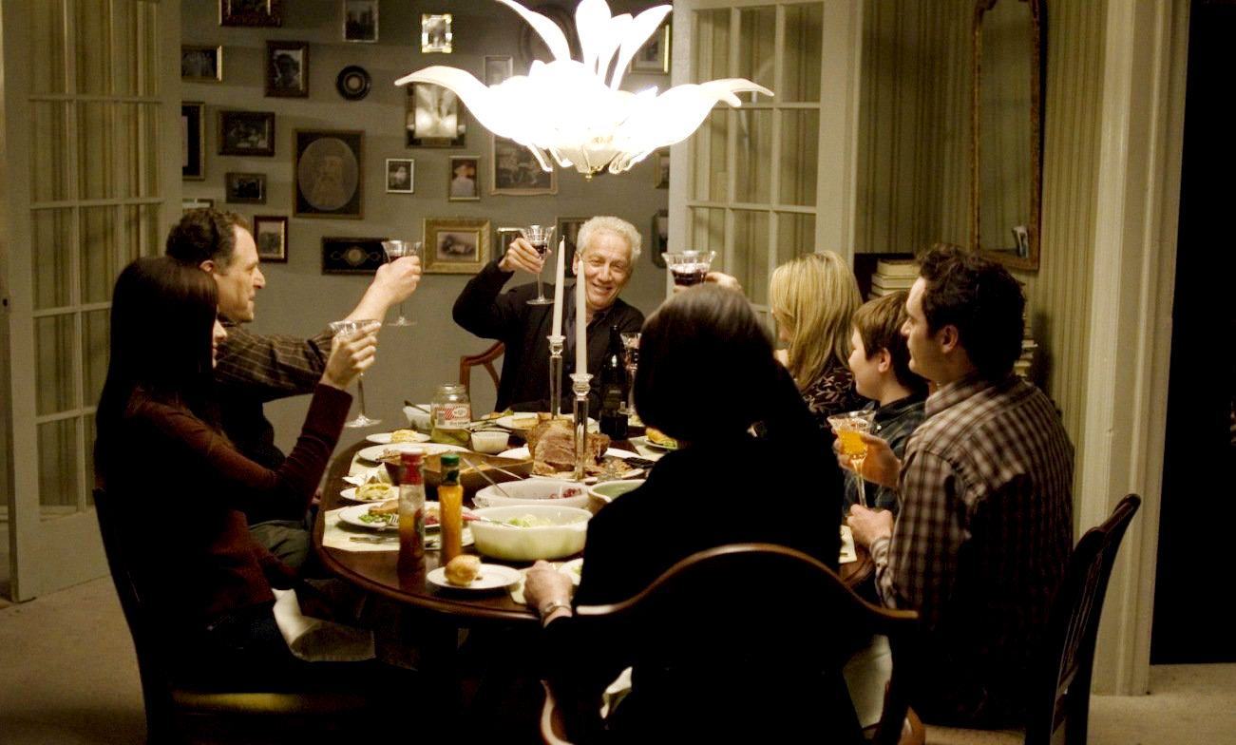
Yet, when the outside world represented in “Two Lovers” by the non-Jewish girl and the inside world of the smothering flat collide, questioning glances are made from both worlds at the hero. Leonard Kraditor, a future debtor, cannot hold an intermediary position as Bobby tried to do in “We Own the Night.”

Stuck in a role

Since Leonard cannot decide on his own which style of life he wants to embrace, he adopts contradictory behaviors that match each of the environments he’s confronted with. Leonard is stuck in a role: that of the crazy pal who sneaks out of his bedroom to dance in a club and that of the committed son who takes out the nice girl his parents like. Leonard believes that each woman is the feminine counterpart to his dual personality. Sarah is the Jewish woman respectful of tradition. Michelle (Gwyneth Paltrow), a seductive woman engaged in multiple relationships, embodies fragility and innocence, spontaneity and eccentricity. In fact, Leonard is so reified that he doesn’t notice that his lovers are more than specific types of woman. Leonard is caught up in a web of perceptions and moral representations. Since what is born outside the family is condemned to secrecy, Leonard doesn’t talk about the girl next door, the crazy “shikse” woman. He sends her short messages and conceals himself from his mother’s gaze to answer her calls etc... What is conceived as contrary to family ethics is filmed in a harsh way. Thus, the two love scenes mirror the family representations of women. Leonard has sex with Sandra at his parents’ house, in his bedroom, surrounded by all his teenage belongings. However, Leo makes love to Michelle on the landing, on a crisp day, secluded from the rest of the world. Both lovers are shivering, hidden there, but also at the mercy of any onlooker. Leo fears to be discovered but secretly hopes to be in order to reconcile with his crazy self. In my opinion, Leonard fails to achieve the real honest love relationship he could have been proud of, i.e. with Michelle, because he eventually comes to consider her as his parents did: a white unbalanced woman, an opportunist with no respect for religion, family and love, a dangerous girl doomed to secret love affairs with married men.
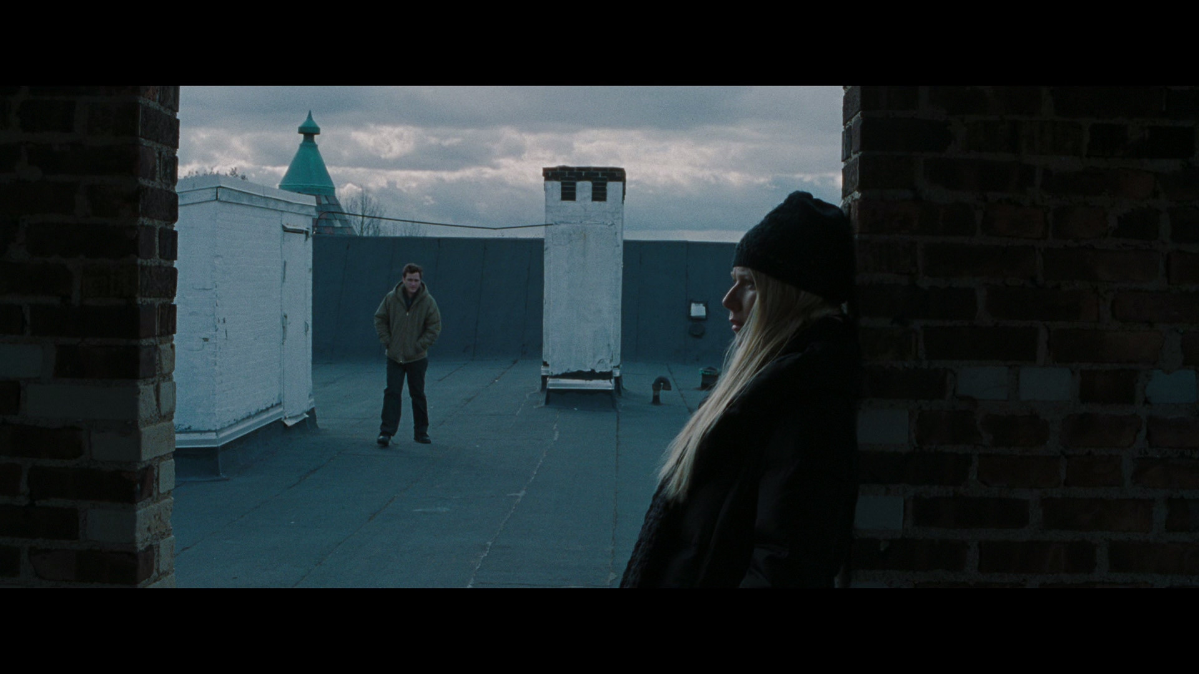
As Bobby couldn’t see that his brother was more than the serious son and that Marat was more than the concerned lawful godfather, Leonard fails to realize that Michelle is more than an egotistical nut. Both women pursue secret agendas consciously or not.
Sarah could have married anyone, she had many suitors. Yet, she chose the hesitating Leo, with no professional prospects and no love for her. Through marriage, what is ascertained is ethnicity and family heritage. Leo is chosen because he’s the grandson of traditional tailors. Through marriage, Sarah’s family will inherit the tradition that fails them in their commercial business. And they’ll be able to smother it while at the same time boasting about it. Michelle fell for Leonard because in spite of or perhaps because of his marked ethnicity, she could flee from the sad role assigned to her by her social status.
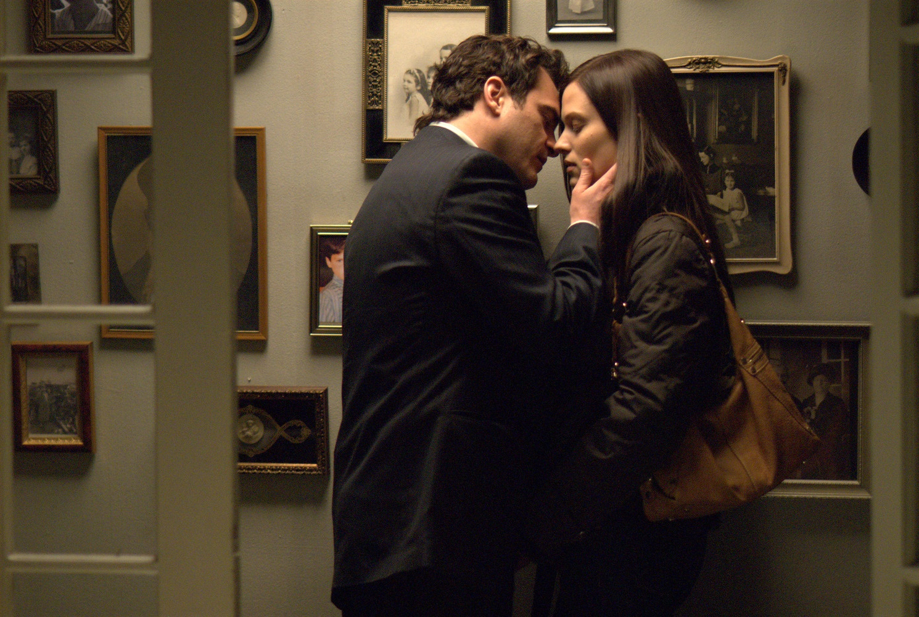

Conclusion

The epilogue of Gray’s two movies is bitter sweet. The dreams of personal fulfillment outside the limits dictated by the heroes’ ethnic heritage leave room for the assertion of a family moral code that shows through the choices made by both protagonists. Rebellious to their paternal authority, Bobby and Leonard eventually surrender to the delusively secure environment praised and embodied by their family’s social and professional environment.
When ethnicity cannot express itself through language (first names, puns or songs), when images or glances fail to reveal the family impetus, objects reflect the lack of liberty deliberately embraced by characters. Thus, a glove found on the beach drives Leo back into his Jewish girlfriend’s arms. The glove is the promise of a smooth future where the true self is cajoled and protected from the outside world until it ceases to exist and starts conforming itself to a past dream. By filming two outcasts whose personal pursuits and emotional attachments upset or surprise the community they belong to originally, Gray questions the liberty of the individual against the weight of familial traditions. He also defines power relationships that express themselves through the manipulation of a language that conceals or reveals its ethnicity. Eventually, by linking a specific milieu to a marked territory (the mingling crowds at the disco, the Jewish family at the Bar Mitzvah near Brighton Beach), he superimposes the invisible psychodynamic barriers imposed on the self or created by the self on the shifting geographic frontiers of the different communities represented in New York City.

See Roget Ebert’s review of The Yards: http://www.rogerebert.com/reviews/the-yards-2000 And more recently: Alpert, Robert. “The Films of James Gray: Old Testament Narratives” in Senses of Cinema, issue 65, December 2012. http://sensesofcinema.com/2012/feature-articles/the-films-of-james-gray-old-testament-narratives/

